Dong
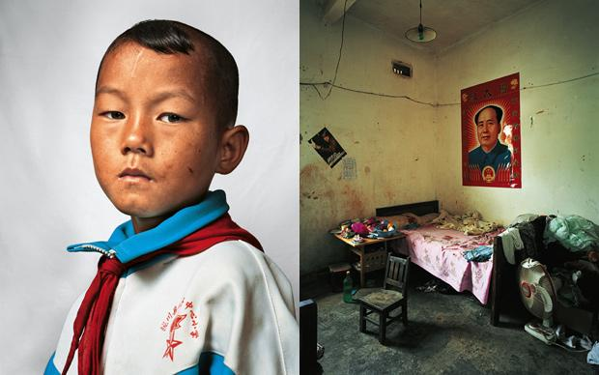
Dong, nine, lives in Yunnan province in south-west China with his parents, sister and grandfather. He shares a room with his sister and parents. The family own just enough land to grow their own rice and sugarcane. Dong’s school is 20 minutes’ walk away. He enjoys writing and singing. Most evenings, he spends one hour doing his homework and one hour watching television. When he is older, Dong would like to be a policeman.

Dong
Dong, nine, lives in Yunnan province in south-west China with his parents, sister and grandfather. He shares a room with his sister and parents. The family own just enough land to grow their own rice and sugarcane. Dong’s school is 20 minutes’ walk away. He enjoys writing and singing. Most evenings, he spends one hour doing his homework and one hour watching television. When he is older, Dong would like to be a policeman.

Indira
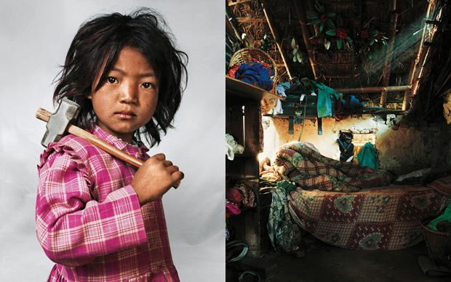
Indira, seven, lives with her parents, brother and sister near Kathmandu in Nepal. Her house has only one room, with one bed and one mattress. At bedtime, the children share the mattress on the floor. Indira has worked at the local granite quarry since she was three. The family is very poor so everyone has to work. There are 150 other children working at the quarry. Indira works six hours a day and then helps her mother with household chores. She also attends school, 30 minutes’ walk away. Her favourite food is noodles. She would like to be a dancer when she grows up.

Indira
Indira, seven, lives with her parents, brother and sister near Kathmandu in Nepal. Her house has only one room, with one bed and one mattress. At bedtime, the children share the mattress on the floor. Indira has worked at the local granite quarry since she was three. The family is very poor so everyone has to work. There are 150 other children working at the quarry. Indira works six hours a day and then helps her mother with household chores. She also attends school, 30 minutes’ walk away. Her favourite food is noodles. She would like to be a dancer when she grows up.

Kaya
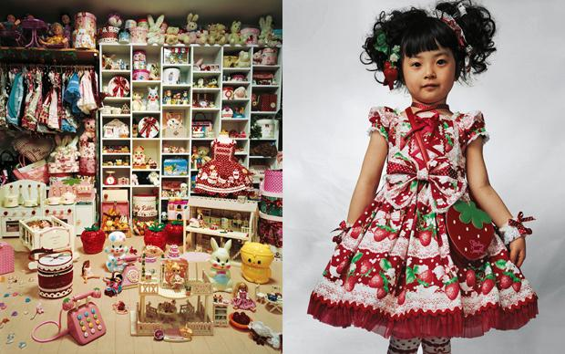
Kaya, four, lives with her parents in a small apartment in Tokyo, Japan. Her bedroom is lined from floor to ceiling with clothes and dolls. Kaya’s mother makes all her dresses – Kaya has 30 dresses and coats, 30 pairs of shoes and numerous wigs. When she goes to school, she has to wear a school uniform. Her favourite foods are meat, potatoes, strawberries and peaches. She wants to be a cartoonist when she grows up.

Kaya
Kaya, four, lives with her parents in a small apartment in Tokyo, Japan. Her bedroom is lined from floor to ceiling with clothes and dolls. Kaya’s mother makes all her dresses – Kaya has 30 dresses and coats, 30 pairs of shoes and numerous wigs. When she goes to school, she has to wear a school uniform. Her favourite foods are meat, potatoes, strawberries and peaches. She wants to be a cartoonist when she grows up.

Thais
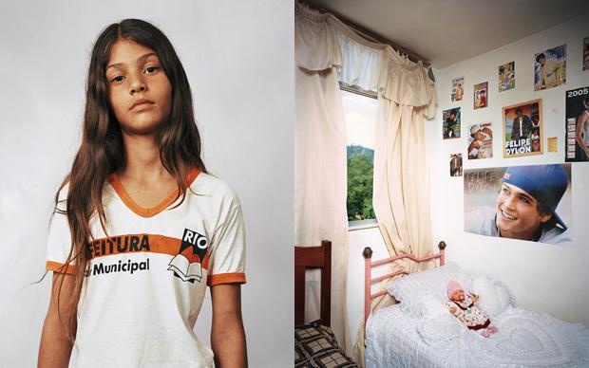
Thais, 11, lives with her parents and sister on the third floor of a block of flats in Rio de Janeiro, Brazil. She shares a bedroom with her sister. They live in the Cidade de Deus (‘City of God’) neighbourhood, which used to be notorious for its gang rivalry and drug use. Since the 2002 film City of God, it has undergone major improvements. Thais is a fan of Felipe Dylon, a pop singer, and has posters of him on her wall. She would like to be a model.

Thais
Thais, 11, lives with her parents and sister on the third floor of a block of flats in Rio de Janeiro, Brazil. She shares a bedroom with her sister. They live in the Cidade de Deus (‘City of God’) neighbourhood, which used to be notorious for its gang rivalry and drug use. Since the 2002 film City of God, it has undergone major improvements. Thais is a fan of Felipe Dylon, a pop singer, and has posters of him on her wall. She would like to be a model.

Tzvika
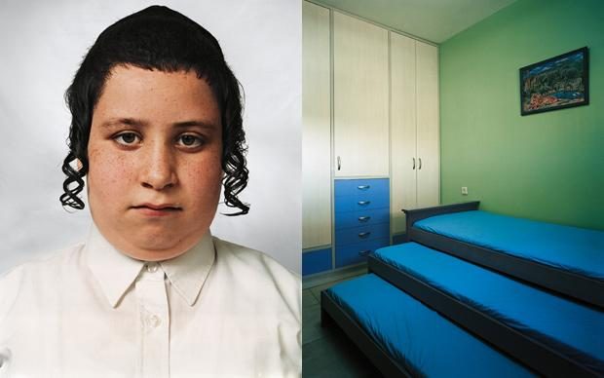
Tzvika, nine, lives in an apartment block in Beitar Illit, an Israeli settlement in the West Bank. It is a gated community of 36,000 Haredi (Orthodox) Jews. Televisions and newspapers are banned from the settlement. The average family has nine children, but Tzvika has only one sister and two brothers, with whom he shares his room. He is taken by car to school, a two-minute drive. Sport is banned from the curriculum. Tzvika goes to the library every day and enjoys reading the holy scriptures. He also likes to play religious games on his computer. He wants to become a rabbi, and his favourite food is schnitzel and chips.

Tzvika
Tzvika, nine, lives in an apartment block in Beitar Illit, an Israeli settlement in the West Bank. It is a gated community of 36,000 Haredi (Orthodox) Jews. Televisions and newspapers are banned from the settlement. The average family has nine children, but Tzvika has only one sister and two brothers, with whom he shares his room. He is taken by car to school, a two-minute drive. Sport is banned from the curriculum. Tzvika goes to the library every day and enjoys reading the holy scriptures. He also likes to play religious games on his computer. He wants to become a rabbi, and his favourite food is schnitzel and chips.

Lamine
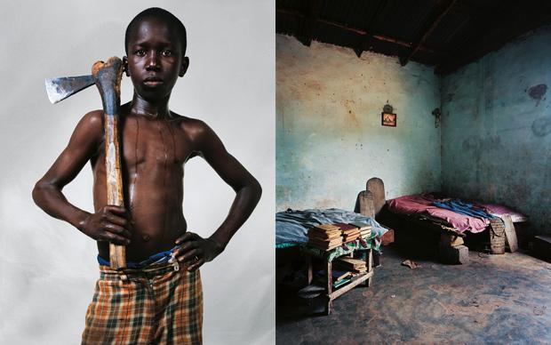
Lamine (above), 12, lives in Senegal. He is a pupil at the village Koranic school, where no girls are allowed. He shares a room with several other boys. The beds are basic, some supported by bricks for legs. At six every morning the boys begin work on the school farm, where they learn how to dig, harvest maize and plough the fields using donkeys. In the afternoon they study the Koran. In his free time Lamine likes to play football with his friends.

Lamine
Lamine (above), 12, lives in Senegal. He is a pupil at the village Koranic school, where no girls are allowed. He shares a room with several other boys. The beds are basic, some supported by bricks for legs. At six every morning the boys begin work on the school farm, where they learn how to dig, harvest maize and plough the fields using donkeys. In the afternoon they study the Koran. In his free time Lamine likes to play football with his friends.

Nantio
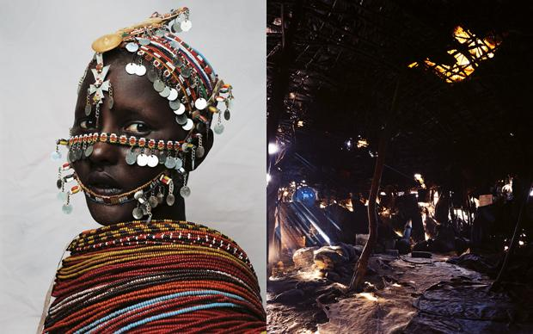
Nantio, 15, is a member of the Rendille tribe in northern Kenya. She has two brothers and two sisters. Her home is a tent-like dome made from cattle hide and plastic, with little room to stand. There is a fire in the middle, around which the family sleep. Nantio’s chores include looking after the goats, chopping firewood and fetching water. She went to the village school for a few years but decided not to continue. Nantio is hoping a moran (warrior) will select her for marriage. She has a boyfriend now, but it is not unusual for a Rendille woman to have several boyfriends before marriage. First, she will have to undergo circumcision, as is the custom

Nantio
Nantio, 15, is a member of the Rendille tribe in northern Kenya. She has two brothers and two sisters. Her home is a tent-like dome made from cattle hide and plastic, with little room to stand. There is a fire in the middle, around which the family sleep. Nantio’s chores include looking after the goats, chopping firewood and fetching water. She went to the village school for a few years but decided not to continue. Nantio is hoping a moran (warrior) will select her for marriage. She has a boyfriend now, but it is not unusual for a Rendille woman to have several boyfriends before marriage. First, she will have to undergo circumcision, as is the custom

Joey
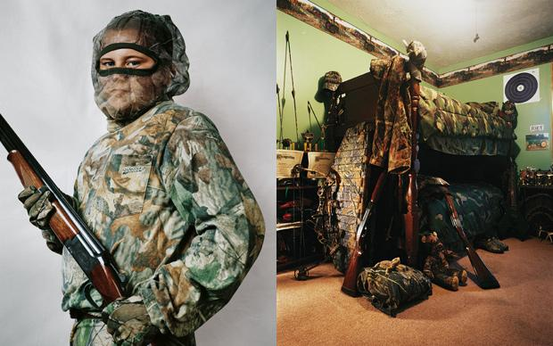
Joey (below), 11, lives in Kentucky, USA, with his parents and older sister. He regularly accompanies his father on hunts. He owns two shotguns and a crossbow and made his first kill – a deer – at the age of seven. He is hoping to use his crossbow during the next hunting season as he has become tired of using a gun. He loves the outdoor life and hopes to continue hunting into adulthood. His family always cook and eat the meat from the animal they have shot. Joey does not agree that an animal should be killed just for sport. When he is not out hunting, Joey attends school and enjoys watching television with his pet bearded dragon lizard, Lily.

Joey
Joey (below), 11, lives in Kentucky, USA, with his parents and older sister. He regularly accompanies his father on hunts. He owns two shotguns and a crossbow and made his first kill – a deer – at the age of seven. He is hoping to use his crossbow during the next hunting season as he has become tired of using a gun. He loves the outdoor life and hopes to continue hunting into adulthood. His family always cook and eat the meat from the animal they have shot. Joey does not agree that an animal should be killed just for sport. When he is not out hunting, Joey attends school and enjoys watching television with his pet bearded dragon lizard, Lily.

Jasmine
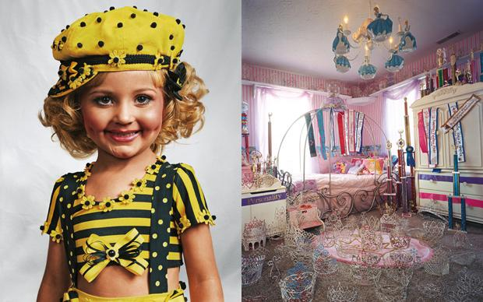
Jasmine (‘Jazzy’), four, lives in a big house in Kentucky, USA, with her parents and three brothers. Her house is in the countryside, surrounded by farmland. Her bedroom is full of crowns and sashes that she has won in beauty pageants. She has entered more than 100 competitions. Her spare time is taken up with rehearsal. She practises her stage routines every day with a trainer. Jazzy would like to be a rock star when she grows up.

Jasmine
Jasmine (‘Jazzy’), four, lives in a big house in Kentucky, USA, with her parents and three brothers. Her house is in the countryside, surrounded by farmland. Her bedroom is full of crowns and sashes that she has won in beauty pageants. She has entered more than 100 competitions. Her spare time is taken up with rehearsal. She practises her stage routines every day with a trainer. Jazzy would like to be a rock star when she grows up.

